SOFTWARE REQUIREMENT SPECIFICATION (SRS)

COMPOUND SYSTEM UMP (COSYS)

2013

AUTHOR NAME

[Type the company name]

To be submitted to the Software Planning & Requirement Workshop

Bachelor of Computer Science (Software Engineering)

# DOCUMENT APPROVAL

|  |  |  |
| --- | --- | --- |
|  | **Name** | **Date** |
| **Authenticated by:**  _______________________  Project Manager |  |  |
| **Approved by:**  _______________________    Client |  |  |

Software :

Archiving Place :

Copies Available :

# TABLE OF CONTENTS

DOCUMENT APPROVAL ii

TABLE OF CONTENTS iii

LIST OF FIGURES Error! Bookmark not defined.

LIST OF TABLES Error! Bookmark not defined.

LIST OF APPENDIXES Error! Bookmark not defined.

1. INTRODUCTION 1-3

1.1 PURPOSE 1

1.2 PROBLEM STATEMENT 1

1.3 SYSTEM OVERVIEW 2

1.4 REFERENCES 2

1.5 DOCUMENT OVERVIEW 3

2. PRODUCT DESCRIPTION 4-11

2.1 PRODUCT PERSPECTIVE 4

2.2 SYSTEM INTERFACES 5

2.3 PRODUCT FUNCTIONS 6-8

2.4 USER CHARACTERISTICS 9

2.5 CONSTRAINTS 10

2.6 ASSUMPTIONS AND DEPENDENCIES 11

3. SPECIFIC REQUIREMENTS 12-32

3.1 EXTERNAL INTERFACE REQUIREMENTS 12-17

3.1.1 USER INTERFACES 12-16

3.1.2 HARDWARE INTERFACES 17

3.1.3 SOFTWARE INTERFACES 17

3.2 SOFTWARE PRODUCT FEATURES 18-29

3.2.1 USE CASE NAME 18-29

3.3 REQUIREMENTS TRACEBILITY 30-32

4. ACRONYMS AND ABBREVIATION 33-34

LIST OF FIGURES

Figure 2.1 Context Diagram for Compound System UMP (COSYS)4

Figure 2.3 (a) 5 Module for Student in Compound System UMP (COSYS)6

Figure 2.3 (b) 5 Module for Admin in Compound System UMP (COSYS)7

Figure 3.1 (a) Login Interface in Compound System UMP (COSYS)12

Figure 3.1 (b) Student Interface in Compound System UMP (COSYS)13

Figure 3.1 (c) Felo Interface in Compound System UMP (COSYS)14

Figure 3.1 (d) Principal Interface in Compound System UMP (COSYS)15

Figure 3.1 (e) Treasurer Interface in Compound System UMP (COSYS)16

# [1]

# LIST OF TABLE

Table 3.1 Software Interface 17

Table 3.2 Use Case for login 18-19

Table 3.3 Use Case for Profile Information 20-21

Table 3.4 Use Case for Student Summon Section 22-23

Table 3.5 Use Case for Felo Summon Section 24-25

Table 3.6 Use Case for Principal Summon Section 26-27

Table 3.7 Use Case for Treasurer Summon Section 28-29

Table 3.8 Requirements Traceability 30-32

Table 4.1 Definition 33

Table 4.2 Acronyms 34

# LIST OF APPENDIX

APPENDIX A (SEQUENCE DIAGRAM) 35

Appendix A-1 Student 36

Appendix A-2 Felo 37

Appendix A-3 Principal 38

Appendix A-4 Treasurer 39

APPENDIX B (GRAPHICAL USER INTERFACE) 40

Appendix B-1 Login Interface 41

Appendix B-2 view student profile 42

Appendix B-3 Student view summon status 42

Appendix B-4 Student view payment status 43

Appendix B-5 Student appeal page 43

Appendix B-6 View felo profile 44

Appendix B-7 Felo update summon 44

Appendix B-8 View principal profile 45

Appendix B-9 Principal update appeal 45

Appendix B-10 Principal view Summon Information 46

Appendix B-11 View treasurer profile 47

Appendix B-12 Treasurer update student payment 47

1. INTRODUCTION

## 1.1 PURPOSE

The purpose of this document is to specify the functions and requirements for the Compound System UMP (COSYS). This document will be used as the based for the developers to acknowledge what to be expected from the system and how the components cooperate with each other in the system environments. Upon completion, this document will be act a common point of reference for system expectation.

The primary audience of this document includes a Project Manager, System Developer and the end user of the system

## PROBLEM STATEMENT

The purpose to develop the COSYS is to control the inventory using online system because of the current system bring a few constraints.

1. The admin needs to update the student summon using conventional way such as using logbook to record the summon.
2. The admin will lose the student informations because of changes some info about them. This case can make some difficulty to the admin to update the summons’s information.

## SYSTEM OVERVIEW

Compound System UMP (COSYS) is a system for staff and student located at University of Malaysia Pahang. This system developed for manage the compound and appeal with smoothly without any errors and careless mistake but compliment and will be used by two targets of users which are staff and students.

The system is a prototype of web based application system that staff can keep track the record to avoid loss data and replace manual system. The system contains Students section, Felo section, Principal section and Treasurer section.

## REFERENCES

|  |  |
| --- | --- |
| Title | IEEE Recommended Practice for Software Requirements Specifications |
| Version Number | Standard 830-1998 |
| Date | 25 June 1998 |
| Author | Publishing organization The Institute of Electrical and Electronics Engineers, Inc. |
| Access Information | http://ieeexplore.ieee.org/stamp/stamp.jsp?tp&arnumber=720574&userType=inst |

|  |  |
| --- | --- |
| Title | Introduction to system analysis and design |
| Version Number | 0.1 |
| Date | 20 Aug 2010 |
| Author | Publishing organization |
| Access Information | http://media.wiley.com/product_data/excerpt/87/04700747/0470074787.pdf |

|  |  |
| --- | --- |
| Title | Process Models in Software Engineering |
| Version Number | 0.1 |
| Date | 18 Aug 2010 |
| Author | Publishing organization |
| Access Information | http://www.ics.uci.edu/~wscacchi/Papers/SE-Encyc/Process-Models-SE-Encyc.pdf |

## 1.5 DOCUMENT OVERVIEW

This document outline is based on the IEE standard 830 – 1998 for Software Requirement Specification. The explanation of this SRS is broken down into 3 chapters.

**Chapter 1 Introduction**

In this chapter it contains an introduction of the documentation such as the purpose, scope, definitions, acronyms, and abbreviations, references.

**Chapter 2 Overall Descriptions**

In this chapter it stated about overall descriptions of this system including product perspective, system interfaces, user interfaces and system interfaces. It also explains on product function, user characteristics, constraints, assumptions and dependencies.

**Chapter 3 Specific Requirements**

This chapter described the details of the software requirements. This will enable designers to design the system according to the specification and testers to test the system whether it follows the requirements or not. It will go through detailed on external interface requirement, software product features and performance requirements.

# 2. PRODUCT DESCRIPTION

**OVERVIEW**

This section of the SRS should describe the general factors that affect the product and its requirements. This section does not state specific requirements. Instead, it provides a background for those requirements, which are defined in detail in Part 3 of the SRS, and makes them easier to understand.

**2.1** **Product Perspective**

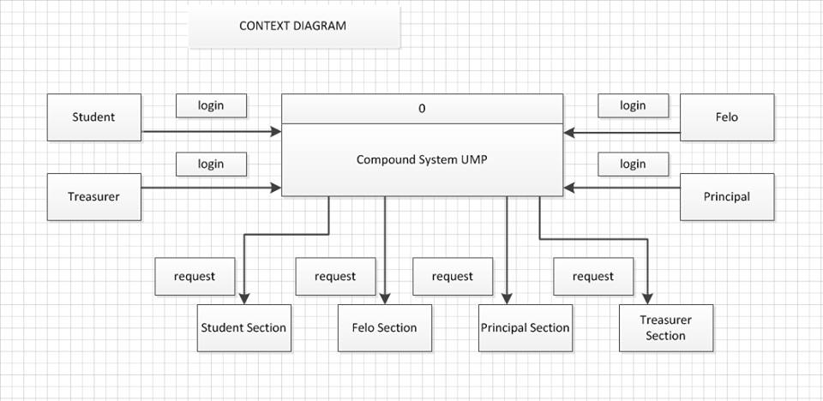

**Figure 2.1** Context Diagram for Compound System UMP (COSYS)

UMP Compound System (COSYS) is a web based application system where the system is capable to run on any internet browser. The function of the COSYS is to easel the inventory in safe way rather than conventional way.

COSYS has four kinds of users which are the Student, Felo, Principal and Treasurer. The system consist of four modules namely Student module, Felo module, Principal module and Treasurer module. For Student module it contains View Summon and Appeal Summon sub module whereby the Felo module contains Manage Student Summon. Besides that, the Principal module required to Manage Appeal Summon by Student and the Treasurer module contains View Student Summon. These entire modules are function without any problems as long as it did not cause any unexpected events such as blackout, system corruption and so on.

### 2.2 System Interfaces

To use this application, user must log in into a system.

**Manage Staff Information**

1. This page only can be accessed by Admin and need to login to access this module.
2. Admin can manage Staff and Student database such as View Information detail, Update Staff Information and Delete Information.

**Manage Summon Information**

1. This page only can be accessed by Admin and need to login to access this section.
2. Admin can Manage Summon Information such as Add data summon and Update data summon.

**Manage Appeal Summon Information**

1. This page only can be accessed by Admin and need to login to access this section.
2. Admin can Manage Appeal Summon Information such as Approve Summon Appeal by student and View Appeal Summon Information.

**Manage Payment Information**

1. This page only can be accessed by Admin and need to login to access this section.
2. Admin can Manage Payment Information such as View Payment Information and Update Status Payment.

## Product Functions

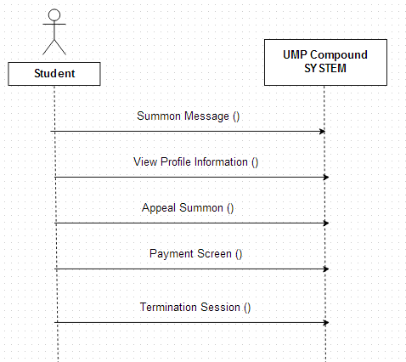

**Figure 2.3 (a)** 5 Module for Student in Compound System UMP (COSYS)

COSYS have 5 module in student page is a Summon Message, View Profile Information, Appeal Summon, Payment Screen and Termination Session.

* + 1. ***Summon Message***

Once student are login the system, Summon Message will appear at the screen display.

***2.3.2 View Profile Information***

During this session, student is able to view their information profile.

***2.3.3 Appeal Summon***

At the Summon Message appear, COSYS shall provide the student with a button appeal for summon to student select for those are want make appeal. (available on Windows COSYS only).

* + 1. ***Payment Screen***

Once a student navigates past the Summon Message, the Compound System UMP will display amount of summon should be pay by students at the Payment Screen.

***2.3.5 Session Termination***

Students may terminate sessions in one of two ways:

* Logging out (no refund is given for unused time)
* Allowing time to expired

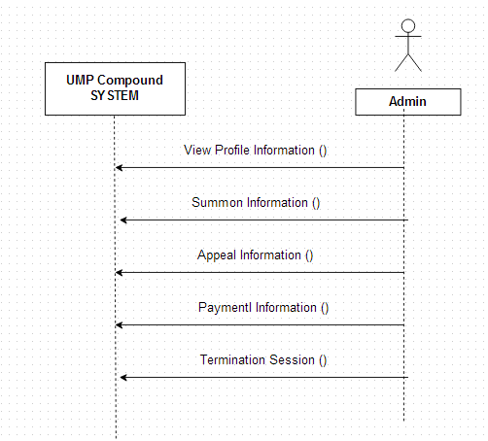

**Figure 2.3 (b)** 5 Module for Admin in Compound System UMP (COSYS)

There are another 5 module in Admin page is a View Profile Information, Summon Information, Appeal Information, Payment Information and Termination Session.

***2.3.6 View Profile Information***

During this session, admin is able to view and update their information profile.

***2.3.7 Summon Information***

After students select the button appeal, COSYS shall provide Summon Information which the admin can view that information.

***2.3.8 Appeal Information***

At the appeal button, the system shall be able to display appeal information student.

***2.3.9 Payment Information***

COSYS will display the list of students who have paid in the Payment Information Screen.

***2.3.10 Session Termination***

Admin may terminate their sessions either by logging out from the system or wait until the allowed time expires automatically.

***2.3.11 Additional Function***

1. 1. Checking the availability of COSYS

* The student can check via Short Message System (SMS)

2. Selection Language

* User can select the language while login COSYS

## 2.4 User Characteristics

There are some minimum characteristic that the target users must have in order to access the system. They are:

**Skill**

* Computer literate, user must at least know well in using keyboard and mouse to interact with the GUI of the system
* Users of this system must be fairly IT literate.
* Have a basic knowledge of using GUI.

**System**

* No experience is needed as the interfaces will provide the user with useful and sufficient information to utilize the system.

**Knowledge in web browsing**

* As the system is a web-based application, user should familiar in browsing the internet to access to the system.
* Trained on how to work with this COSYS.

## 2.5 Constraints

Points below will explain briefly on the constraints which have to be considered during system development process. The constraints stated here are crucial to be taken care of. There are few constraints confronted in order to meet the basic requirement of the system:

* To access the system one must have an internet connection because it is a web based application.
* To access the application one must have an internet connection like Mozilla Firefox installed in the computer with windows XP and above version operating system installed.
* For the functions to run properly, the internet browser must allow client scripting
* Server must be up and run together with the system.
* Hardware and software must fill the minimum specification to run the system
* The users of the application are not entirely sure what they want or need.

## 2.6 Assumptions and Dependencies

***2.6.1 Assumptions***

* This system designed can be run in any of internet browser such as Mozilla Firefox and Internet Explorer.
* This system is assumed that all the users are familiar with the internet browser and computer basic skills.
* To run this system, it only uses quite low memory of RAM for the performance of the application.

***2.6.2 Dependencies***

* The performance of the system application is depends on the memory of ram that the users use when run the system. More ram that users use, more higher the performance of the system application.
* The system also depends on the network also in order to run the system properly.

# 3. SPECIFIC REQUIREMENTS

## External Interface Requirements

### User Interfaces

User interfaces is very important part in a system and it is the part that interacts with user. The user interface is a key and determines the application usability; therefore user interface must be user friendly and meet the user requirements. This is required due to the reason of a user who is inexperience and limited knowledge in using the system. There will be different set of user interfaces display according to their role and responsibilities.

#### 3.1.1.1 Login interface

Login interface provided to user to enter their Username, Password and Categories to login to enter a system.

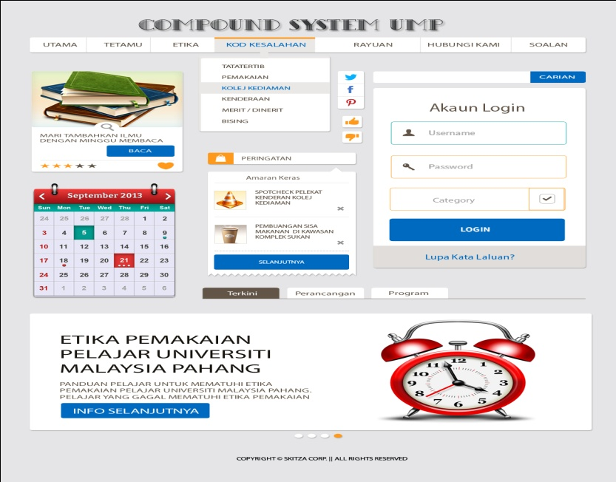

Student, felo, principal and treasurer needs to enter username, password and select categories to login

**Figure 3.1 (a)** Login Interface in Compound System UMP (COSYS)

#### 3.1.1.2 Student interface

Student section interface provided a menu for student section which student can view their profile, view the summon status, view their payment status and also make an appeal to get discount using an online system.

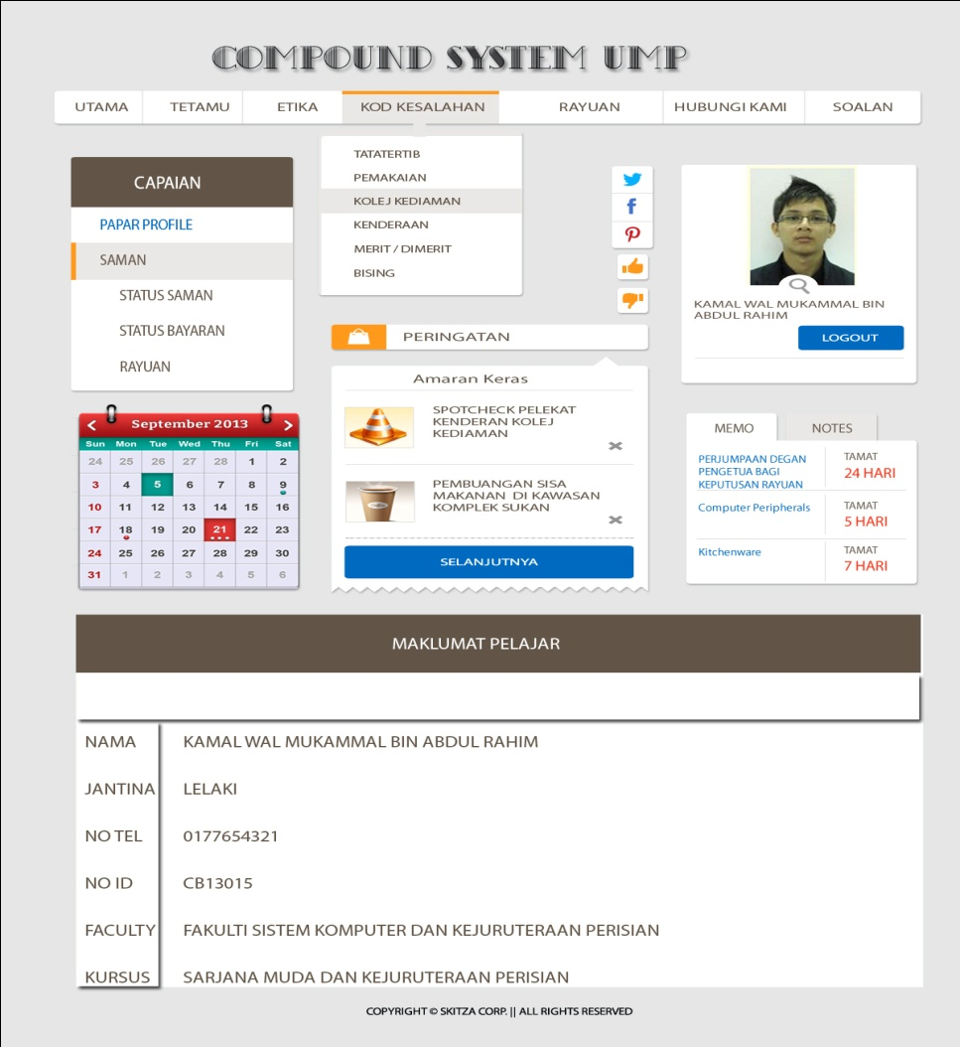

Student can view memo

Student profile is display here

Student can select either to view profile, summon status, payment status and make an appeal

**Figure 3.1 (b)** Student Interface in Compound System UMP (COSYS)

#### 3.1.1.3 Felo interfaces

Felo section interface provided menu for felo section which felo can view summon and update summon record.

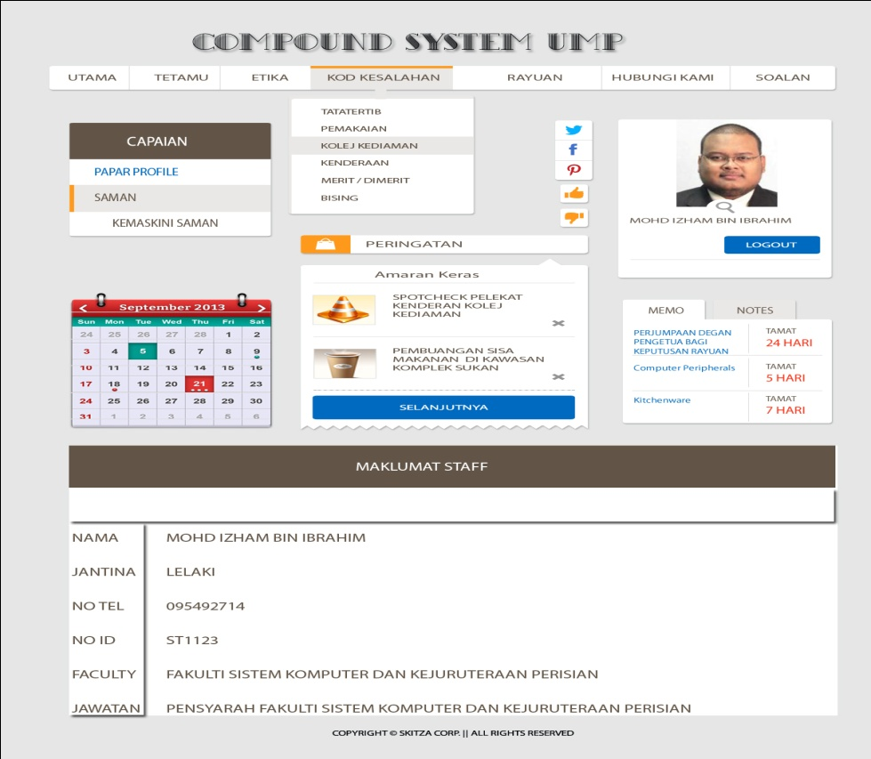

Felo select either to view their profile or update summon

Logout session

**Figure 3.1 (c)** Felo Interface in Compound System UMP (COSYS)

#### 3.1.1.4 Principal interface

In principal section interface, principal can view their profile, update appeal and view summon status.

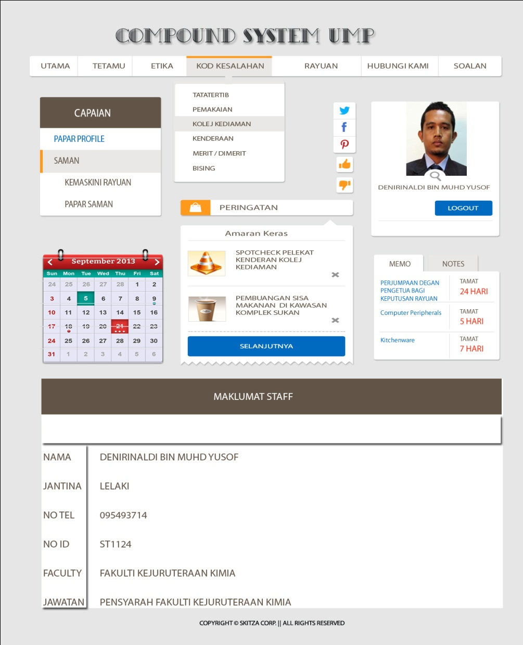

Principal select either to view their profile or update appeal summon and display summon

Logout session

**Figure 3.1 (d)** Principal Interface in Compound System UMP (COSYS)

#### 3.1.1.5 Treasurer interface

Treasurer Section interface provided a menu for admin section which admin can view their profile and update payment.

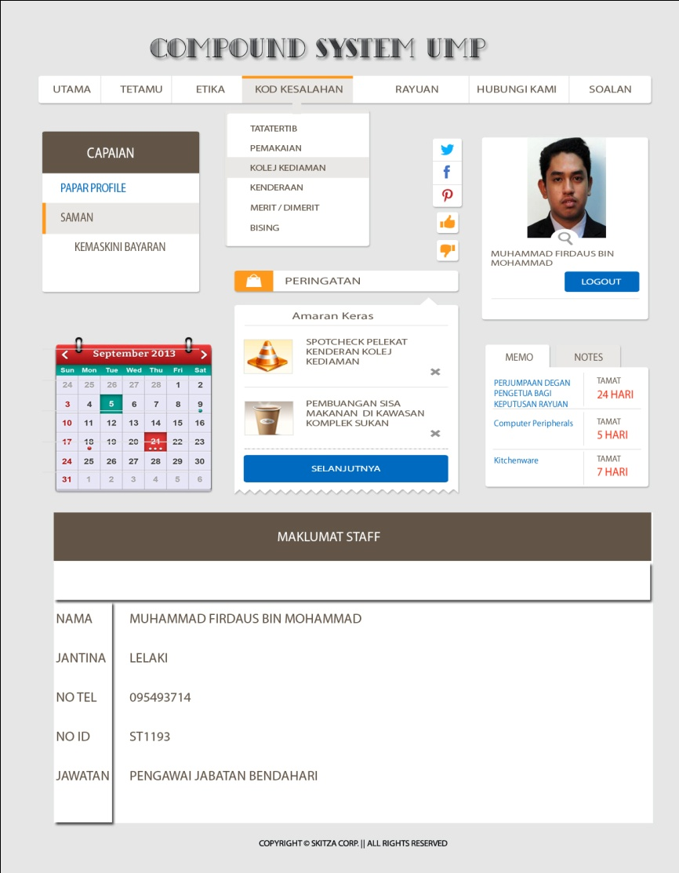

Treasurer can select either to view their profile or update payment status

Logout session

**Figure 3.1 (e)** Treasurer Interface in Compound System UMP (COSYS)

3.1.2 **Hardware Interface**

Not Applicable.

3.1.3 **Software Interface**

The table below indicates all the software that will be used to build the Compound System in UMP (COSYS).

|  |  |
| --- | --- |
| **Software** | **Purpose** |
| Microsoft Windows Operating System  • Windows 7 Professional | • As a platform for a system to run  • Operating system which will be used to develop the system |
| Microsoft Office  • Microsoft Word 2007 & 2010  • Relational Software Architect  • Microsoft Visio 2010 | • Prepare proposal and documentation  • Design and draw chart and diagram |
| Adobe Dreamweaver CS4  Adobe Photoshop | Design interface and generate coding |
| Appserver MySQL PHP MyAdmin | Database for the system; generate database, database management and database platform |
| WinRAR | Compress project files |

**Table 3.1** Software Interface

## 3.2 Software Product Features

### 3.2.1 Use Case for Login

|  |  |
| --- | --- |
| **Use Case ID** | **SRS-COSYS-REQ-100** |
| **Brief Description** | Initiated by the Admin and Student and it provided the capability to login into the Compound System UMP (COSYS) |
| **Actor** | Student, Felo, Principal, Treasurer |
| **Pre-Conditions** | 1. User must have their own username and password. 2. The login page will be displayed. |
| **Basic Flow** | 1. Admin or Student enter their username, password and select categories then click “login” button.   **[SRS-COSYS-REQ-101]**   1. The COSYS checks the username, password and categories.   **[SRS-COSYS-REQ-102]**   1. If username, password and categories is match, continue with next action. 2. Process ends. |
| **Alternative Flow** | Not Applicable |
| **Exception Flow** | * 1. COSYS display “Invalid username and password” message   **[SRS-COSYS-REQ-103]**   * 1. The COSYS waits for a correct value.   2. Process continues. |
| **Post-Conditions** | User access the system. |
| **Rules** | Not Applicable |
| **Constraints** | Not Applicable |
| **Sequence Diagram** | Refer Appendix  **Appendix A-1** Student  **Appendix A-2** Felo  **Appendix A-3** Principal  **Appendix A-4** Treasurer |

Table 3.2 Use Case for login

### 3.2.1 Use Case for Profile Information

|  |  |
| --- | --- |
| **Use Case ID** | **SRS-COSYS-REQ-200** |
| **Brief Description** | Initiated by the User. It provided the capability to view their profile information into the Compound System (COSYS). |
| **Actor** | Student, Felo, Principal, Treasurer |
| **Pre-Conditions** | User authentication by the system. |
| **Basic Flow** | * 1. User enter to view profile section   **[SRS-RISO-REQ-201]**   * 1. User can view their profile in view profile section   **[SRS-RISO-REQ-202]**   1. Process ends. |
| **Alternative Flow** | * 1. Quit. **[SRS-COSYS-REQ-203]**   The User can quit at any time. The user have two option either they can proceed to another menu to view any information or quit from the system. Process ends. |
| **Exception Flow** | 1. The system will prompt a message which stated that “Invalid username and password”. Re-enter username and password. .  **[SRS-COSYS-REQ-204]** 2. The system will wait for the valid username and password. 3. Process continues. |
| **Post-Conditions** | User access the system. |
| **Rules** | Not Applicable |
| **Constraints** | Not Applicable |
| **Sequence Diagram** | Refer Appendix  **Appendix A-1** Student  **Appendix A-2** Felo  **Appendix A-3** Principal  **Appendix A-4** Treasurer |

Table 3.3 Use Case for Profile Information

### 3.2.2 Use Case for Student Summon Section

|  |  |
| --- | --- |
| **Use Case ID** | **SRS-COSYS-REQ-300** |
| **Brief Description** | Initiated by the Student. It provided the capability to view their summon, view payment status and make appeal for the summon into the Compound System (COSYS). |
| **Actor** | Student |
| **Pre-Conditions** | Not Applicable |
| **Basic Flow** | 1. Student enter to summon section   **[SRS-COSYS-REQ-301]**   1. Student can select submenu summon status to view their summon.   **[SRS-COSYS-REQ-302]**   1. Student can select submenu payment status to view their status payment.   **[SRS-COSYS-REQ-303]**   1. Student can select submenu appeal to make appeal for their summon.   **[SRS-COSYS-REQ-304]**   1. Process ends. |
| **Alternative Flow** | 1. Quit. **[SRS-COSYS-REQ-305]**   The Student can quit at any time. The user have two option either they can proceed to another menu to view any information or quit from the system. Process ends. |
| **Exception Flow** | Non Applicable |
| **Post-Conditions** | User access the system. |
| **Rules** | Not Applicable |
| **Constraints** | Not Applicable |
| **Sequence Diagram** | Refer Appendix  **Appendix A-1** Student |

Table 3.4 Use Case for Student Summon Section

### 3.2.3 Use Case Felo Summon Section

|  |  |
| --- | --- |
| **Use Case ID** | **SRS-COSYS-REQ-400** |
| **Brief Description** | Initiated by the Felo. It provided the capability to update the summon that they give to student into the Compound System (COSYS). |
| **Actor** | Felo |
| **Pre-Conditions** | Not Applicable |
| **Basic Flow** | 1. Felo enters to summon section.   **[SRS-COSYS-REQ-401]**   1. Felo can select submenu update summon to view the summon and felo also can add summon into COSYS.   **[SRS-COSYS-REQ-402]**   1. Process ends. |
| **Alternative Flow** | 1. Quit. **[SRS-COSYS-REQ-403]**   The Felo can quit at any time. The user have two option either they can proceed to another menu to view any information or quit from the system. Process ends. |
| **Exception Flow** | Not Applicable |
| **Post-Conditions** | User access the system. |
| **Rules** | Not Applicable |
| **Constraints** | Not Applicable |
| **Sequence Diagram** | Refer Appendix  **Appendix A-2** Felo |

Table 3.5 Use Case for Felo Summon Section

3.2.4 Use Case for Principal Summon Section

|  |  |
| --- | --- |
| **Use Case ID** | **SRS-COSYS-REQ-500** |
| **Brief Description** | Initiated by the Principal. It provided the capability to update the appeal from student and view the summon that student get into the Compound System (COSYS). |
| **Actor** | Principal |
| **Pre-Conditions** | Not Applicable |
| **Basic Flow** | 1. Principal enters to summon section.   **[SRS-COSYS-REQ-501]**   1. Principal can select submenu update appeal to update the result of appeal from student either approve or disapprove into COSYS.   **[SRS-COSYS-REQ-502]**   1. Principal can select submenu view summon to view the students summon.   **[SRS-COSYS-REQ-503]**   1. Process ends. |
| **Alternative Flow** | 1. Quit. **[SRS-COSYS-REQ-504]**   The Principal can quit at any time. The user have two option either they can proceed to another menu to view any information or quit from the system. Process ends. |
| **Exception Flow** | Not Applicable |
| **Post-Conditions** | User access the system. |
| **Rules** | Not Applicable |
| **Constraints** | Not Applicable |
| **Sequence Diagram** | Refer Appendix  **Appendix A-3** Principal |

Table 3.6 Use Case for Principal Summon Section

### 3.2.4 Use Case for Treasurer Summon System

|  |  |
| --- | --- |
| **Use Case ID** | **SRS-COSYS-REQ-600** |
| **Brief Description** | Initiated by the Admin. It provided the capability to update student payment status into the Compound System (COSYS). |
| **Actor** | Treasurer |
| **Pre-Conditions** | Not Applicable |
| **Basic Flow** | 1. Treasurer enters to summon section.   **[SRS-COSYS-REQ-601]**   1. Treasurer can select submenu update payment to update student payment status either paid or not paid into COSYS.   **[SRS-COSYS-REQ-602]**   1. Treasurer can select submenu view summon to view the students summon.   **[SRS-COSYS-REQ-603]**   1. Process ends. |
| **Alternative Flow** | 1. Quit. **[SRS-COSYS-REQ-604]**   The Treasurer can quit at any time. The user have two option either they can proceed to another menu to view any information or quit from the system. Process ends |
| **Exception Flow** | Not Applicable |
| **Post-Conditions** | User access the system. |
| **Rules** | Not Applicable |
| **Constraints** | Not Applicable |
| **Sequence Diagram** | Refer Appendix  **Appendix A-4** Treasurer |

Table 3.7 Use Case for Treasurer Summon Section

**3.3 Requirements Traceability**

|  |  |
| --- | --- |
| **Requirements** | **Description** |
| SRS-RISO-REQ-100 | **Login** |
| SRS-RISO-REQ-101 | Admin or Student enter their username, password and select categories then click “login” button. |
| SRS-RISO-REQ-102 | The COSYS checks the username, password and categories. |
| SRS-RISO-REQ-103 | COSYS display “Invalid username and password” message |
| SRS-RISO-REQ-200 | **Profile Information** |
| SRS-RISO-REQ-201 | User enter to view profile section |
| SRS-RISO-REQ-202 | User can view their profile in view profile section |
| SRS-RISO-REQ-203 | User clicks back button to back to login menu. |
| SRS-RISO-REQ-204 | The system will prompt a message which stated that “Invalid username and password”. |
| SRS-RISO-REQ-300 | **Student Summon Section** |
| SRS-RISO-REQ-301 | Student enter to summon section |
| SRS-RISO-REQ-302 | Student can select submenu summon status to view their summon. |
| SRS-RISO-REQ-303 | Student can select submenu appeal to make appeal for their summon. |
| SRS-RISO-REQ-304 | Student can select submenu appeal to make appeal for their summon. |
| SRS-RISO-REQ-305 | User clicks back button to back to login menu. |
| SRS-RISO-REQ-400 | **Felo Summon Section** |
| SRS-RISO-REQ-401 | Felo enters to summon section. |
| SRS-RISO-REQ-402 | Felo can select submenu update summon to view the summon and felo also can add summon into COSYS. |
| SRS-RISO-REQ-403 | Treasurer can select submenu view summon to view the students summon. |
| SRS-RISO-REQ-404 | User clicks back button to back to login menu. |
| SRS-RISO-REQ-500 | **Principal Summon Section** |
| SRS-RISO-REQ-501 | Principal enters to summon section. |
| SRS-RISO-REQ-502 | Principal can select submenu update appeal to update the result of appeal from student either approve or disapprove into COSYS. |
| SRS-RISO-REQ-503 | Principal can select submenu view summon to view the students summon. |
| SRS-RISO-REQ-504 | User clicks back button to back to login menu |
| SRS-RISO-REQ-600 | Treasurer Summon System |
| SRS-RISO-REQ-601 | Treasurer enters to summon section. |
| SRS-RISO-REQ-602 | Treasurer can select submenu update payment to update student payment status either paid or not paid into COSYS. |
| SRS-RISO-REQ-603 | Treasurer can select submenu view summon to view the students summon. |
| SRS-RISO-REQ-604 | User clicks back button to back to login menu |

Table 3.8 Requirements Traceability

# 4. ACRONYMS AND ABBREVIATION

**4.1 Definition**

|  |  |  |
| --- | --- | --- |
| **No** | **Item** | **Definition** |
| 1 | Graphical User Interface | A program interface that takes advantages of the computer’s graphics capabilities to make the program easier to use. Well-designed graphical user interfaces can free the user from learning complex command languages. On other hands, Staff may find that they work more effectively with a command-driven interface. Especially if they already know the command language. |
| 2 | Internet Browser | Software application which enables a Staff and staff to display and interact with text, images, video, music, games, and others information typically located on a Web page at a website on the World Wide Web (www). |
| 3 | Apache Appserv MySQL | AppServ is a full-featured of Apache, MySQL, PHP, phpMyAdmin. It easy to setup in on clicks.AppServ is an alternative to installing Apache, PHP, or MySQL which take a lot of configuration and time to setup. The objective of Appserv is to setup a web server or database in just a few minutes. |
| 4 | Adobe Dreamweaver CS4 | Software empowers designers and developers to build standards-based websites with confidence. Design visually or directly in code and develop pages that combined with PHP language and MySQL for database management. |

**Table 4.1** Definition

**4.2 Acronyms**

|  |  |  |
| --- | --- | --- |
| **No** | **Item** | **Definition** |
| 1 | PHP | Hypertext Processor |
| 2 | COSYS | Compound System UMP |
| 3 | GUI | Graphical User Interface |
| 4 | REQ | Requirement |
| 9 | SQL | Structured Query Language |
| 12 | SRS | Software Requirement Specification |
| 13 | RAM | Random Access Memory |

**Table 4.2** Acronyms

**APPENDIX A**

**Sequence Diagram**

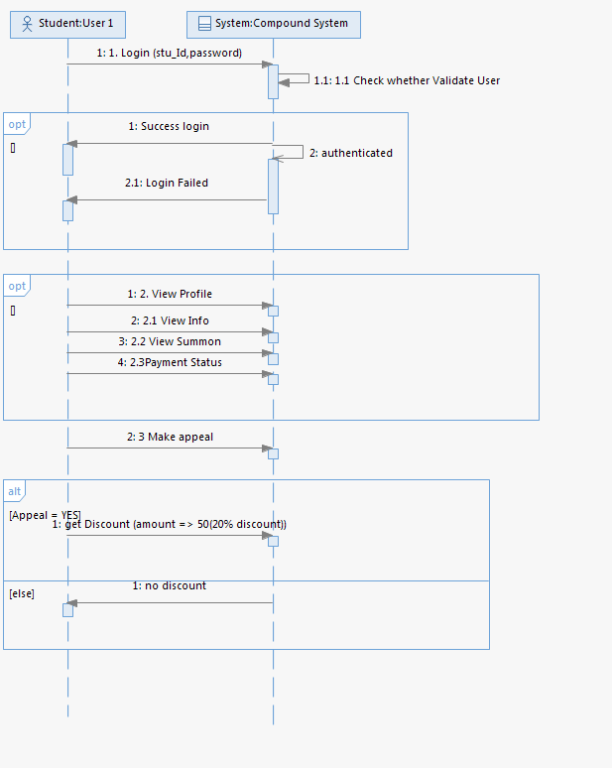

**Appendix A-1** Student

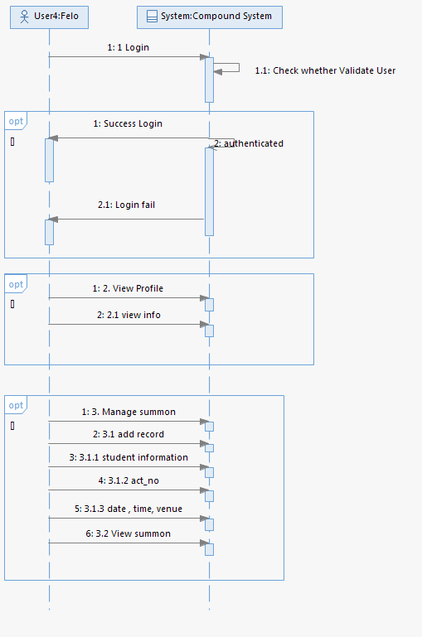

**Appendix A-2** Felo

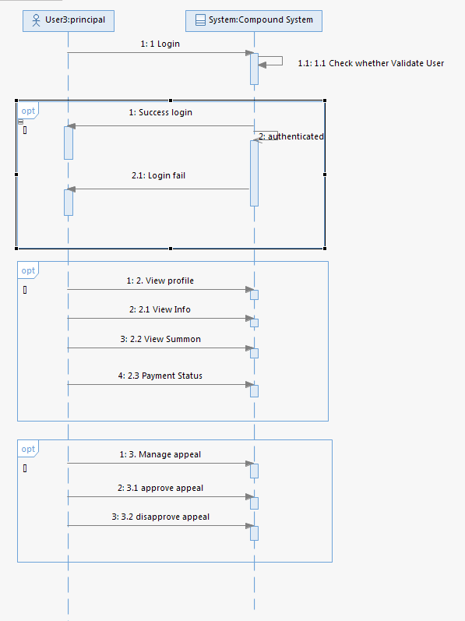

**Appendix A-3** Principal

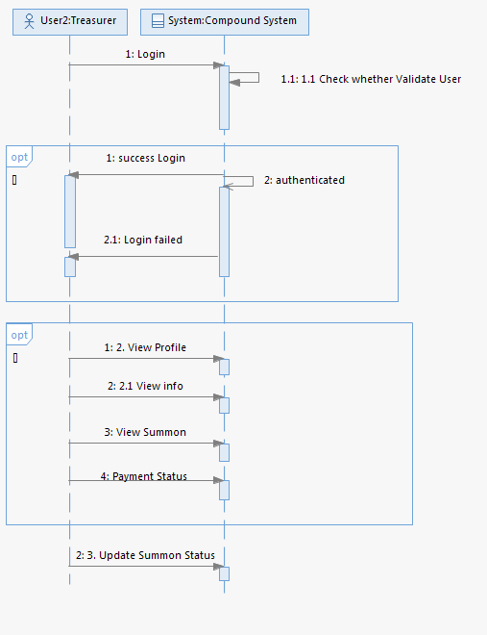

**Appendix A-4** Treasurer

**APPENDIX B**

**Graphical User Interface**

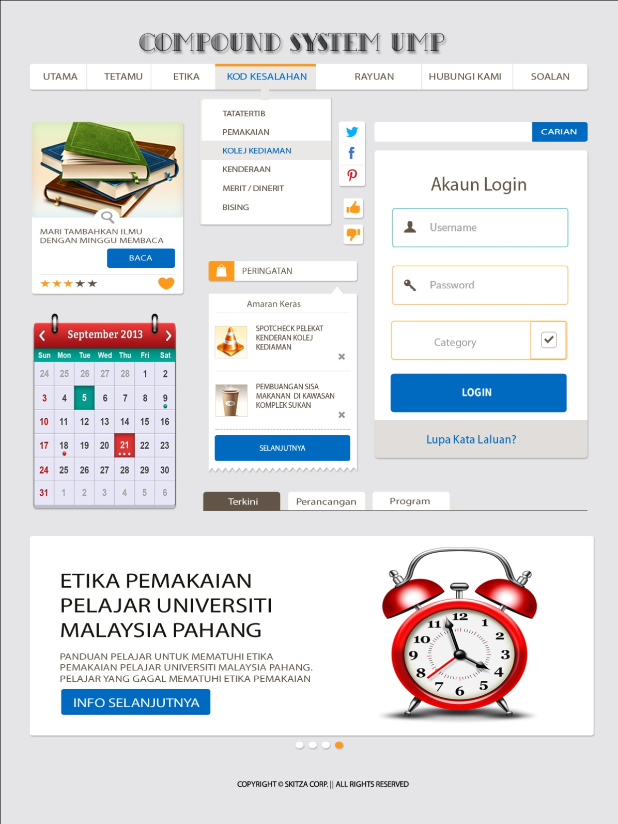

**Appendix B-1** Login Interface

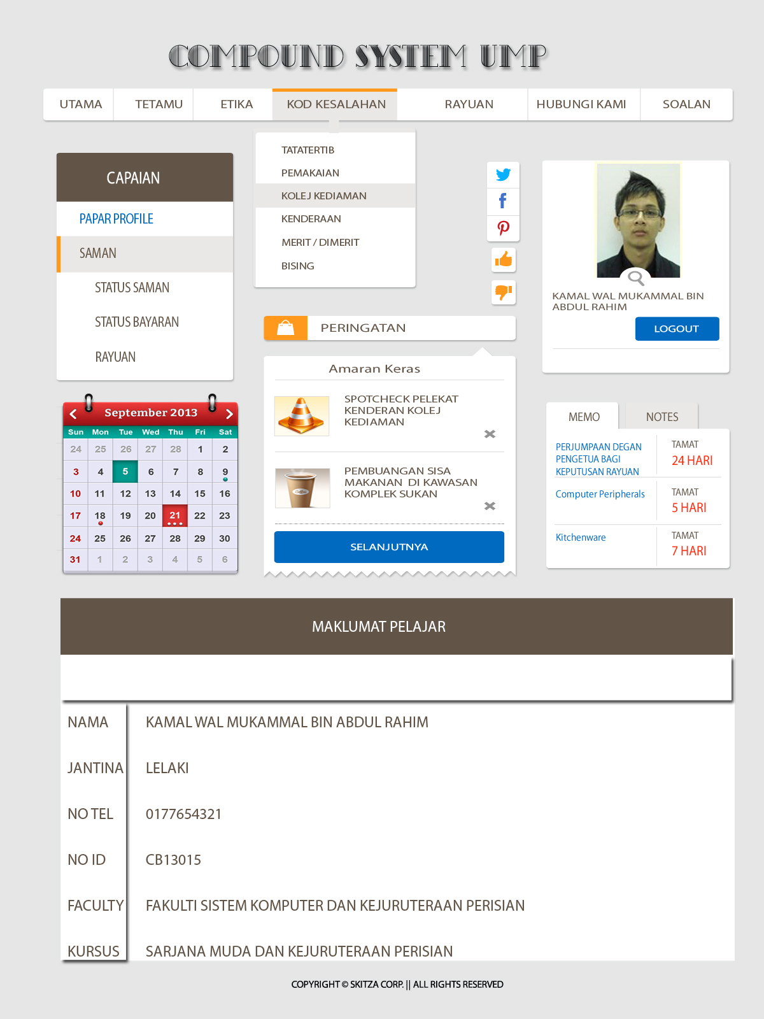

**Appendix B-2** view student profile

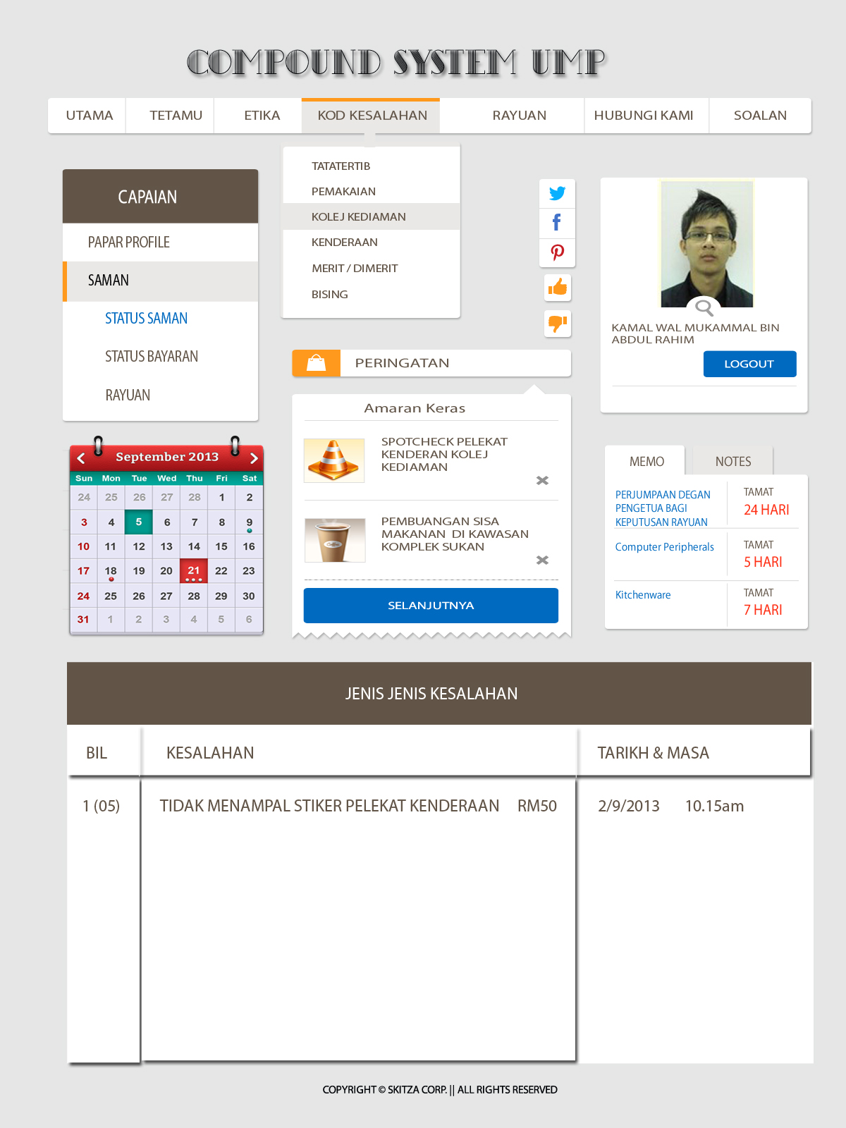

**Appendix B-3** Student view summon status

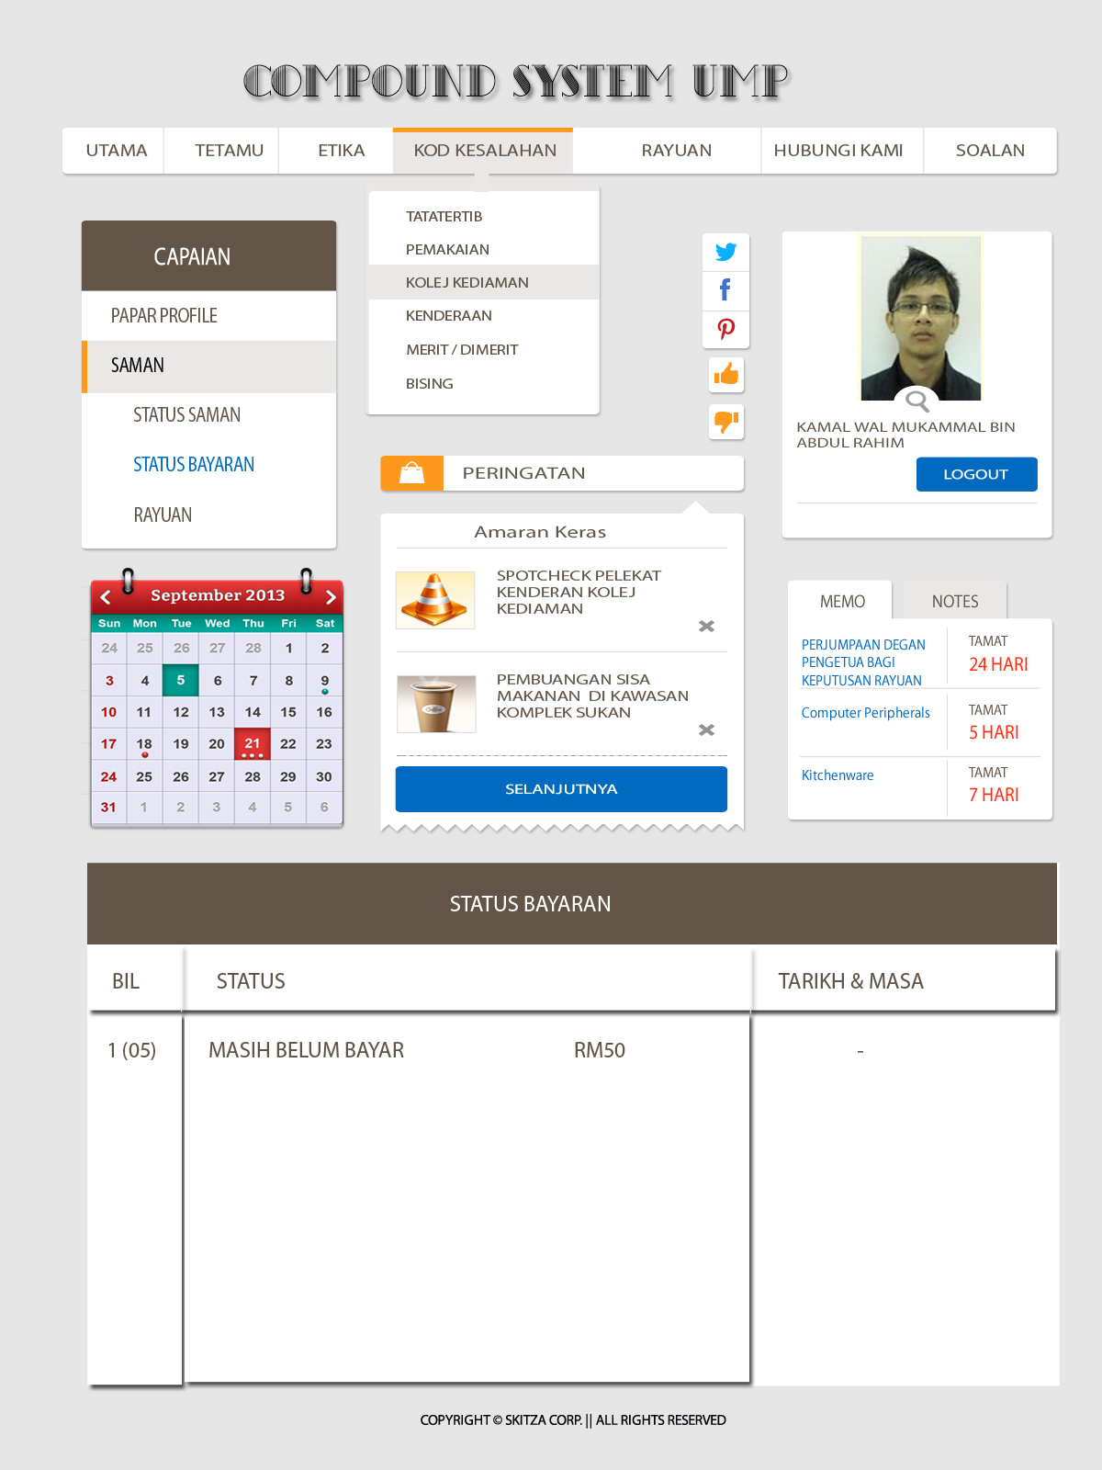

**Appendix B-4** Student view payment status

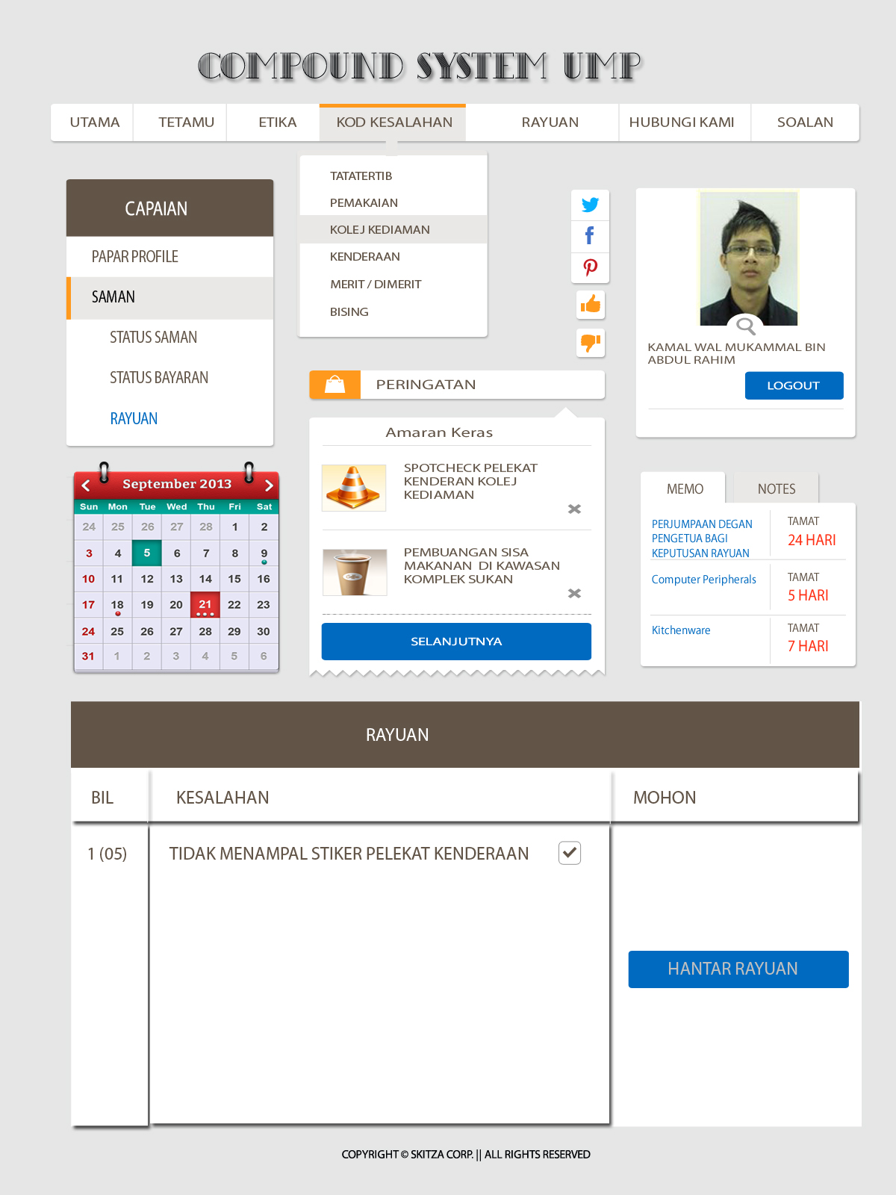

**Appendix B-5** Student appeal page

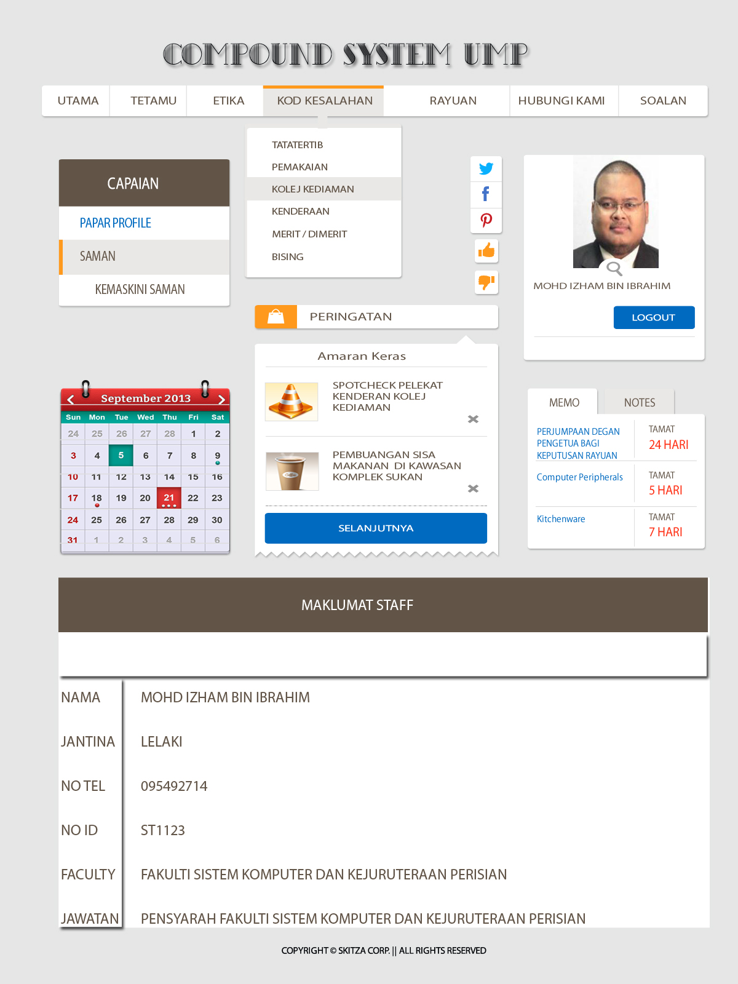

**Appendix B-6** View felo profile

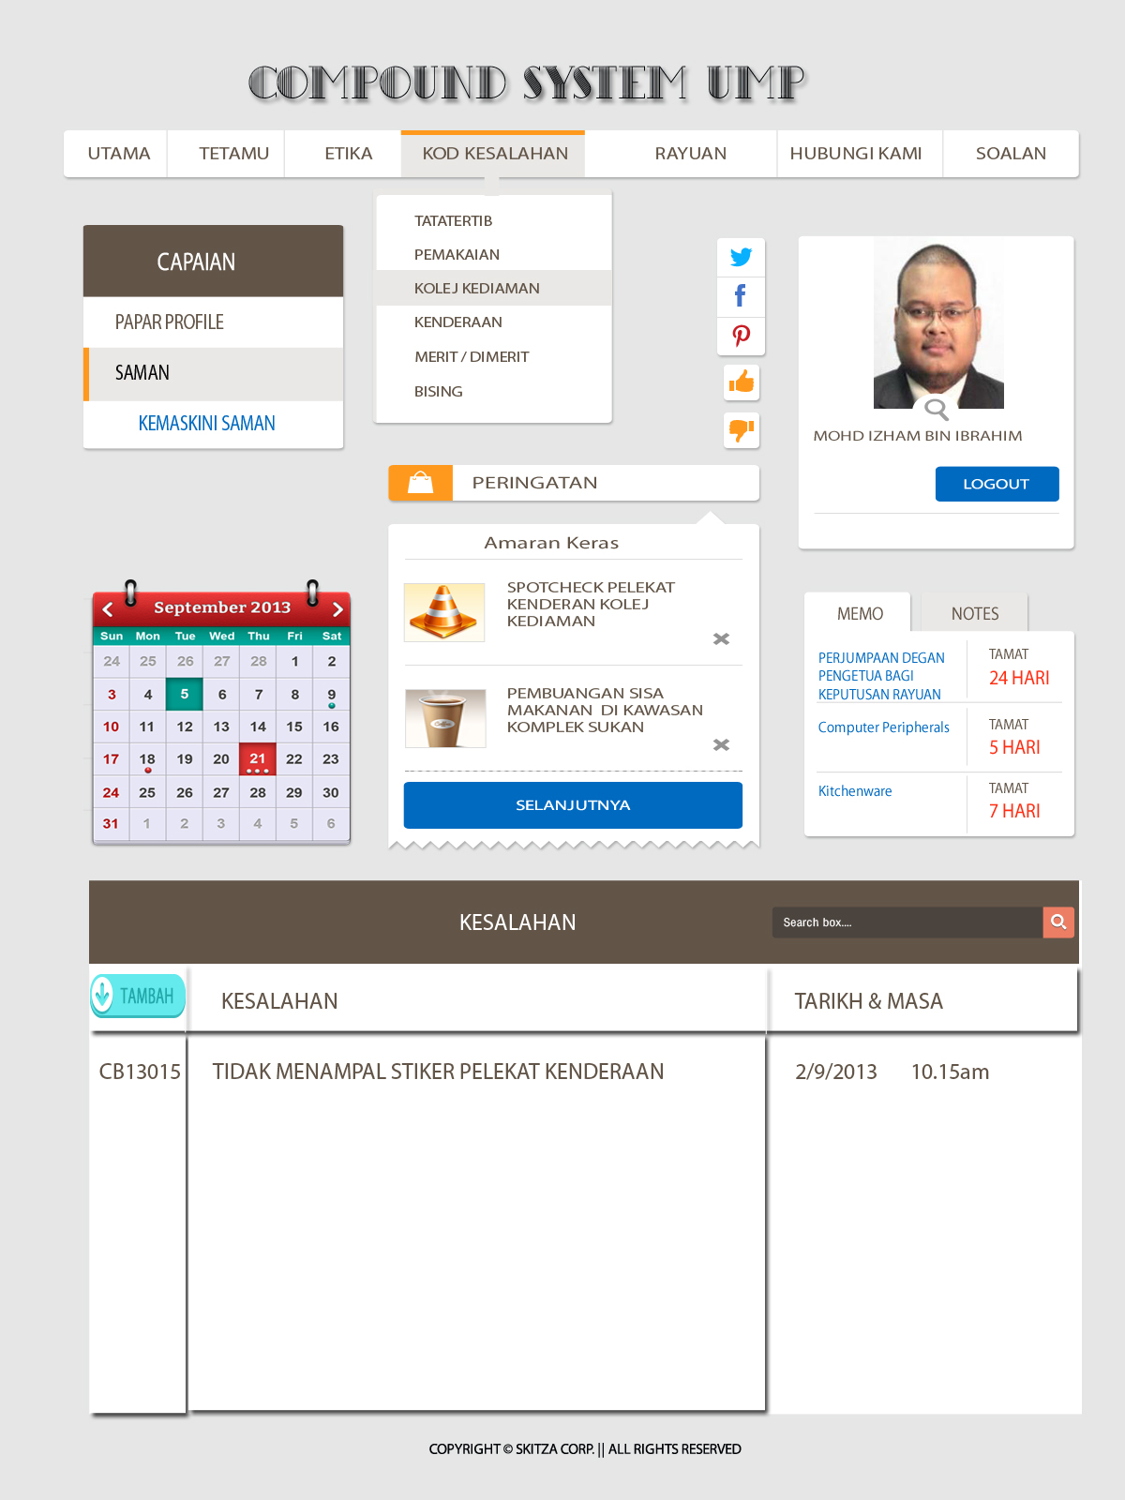

**Appendix B-7** Felo update summon

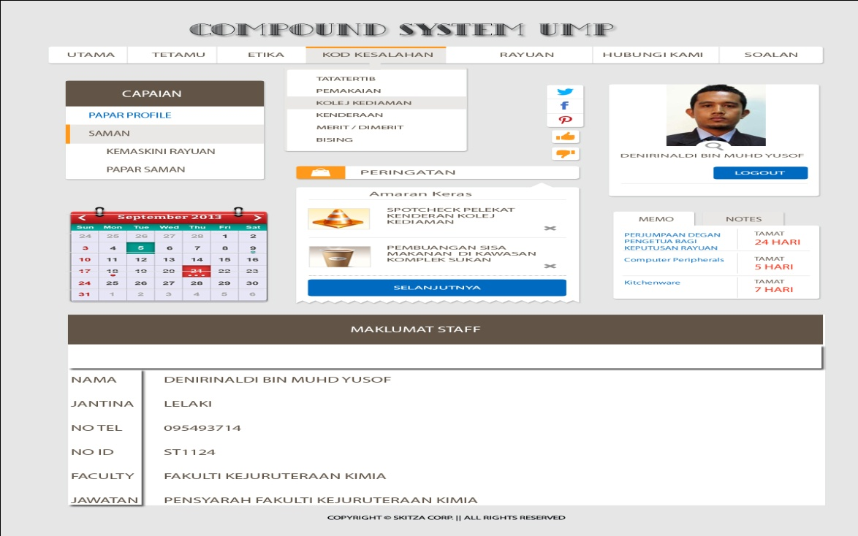

**Appendix B-8** View principal profile

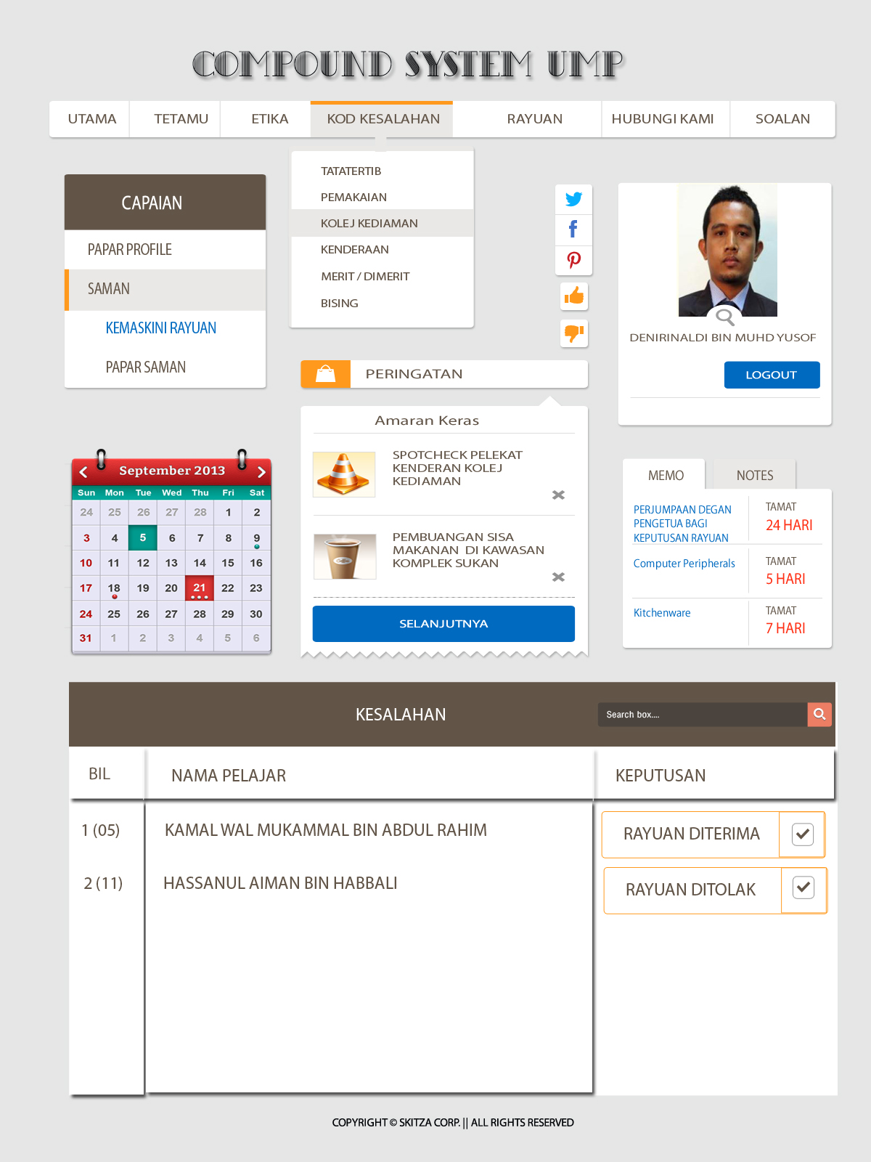

**Appendix B-9** Principal update appeal

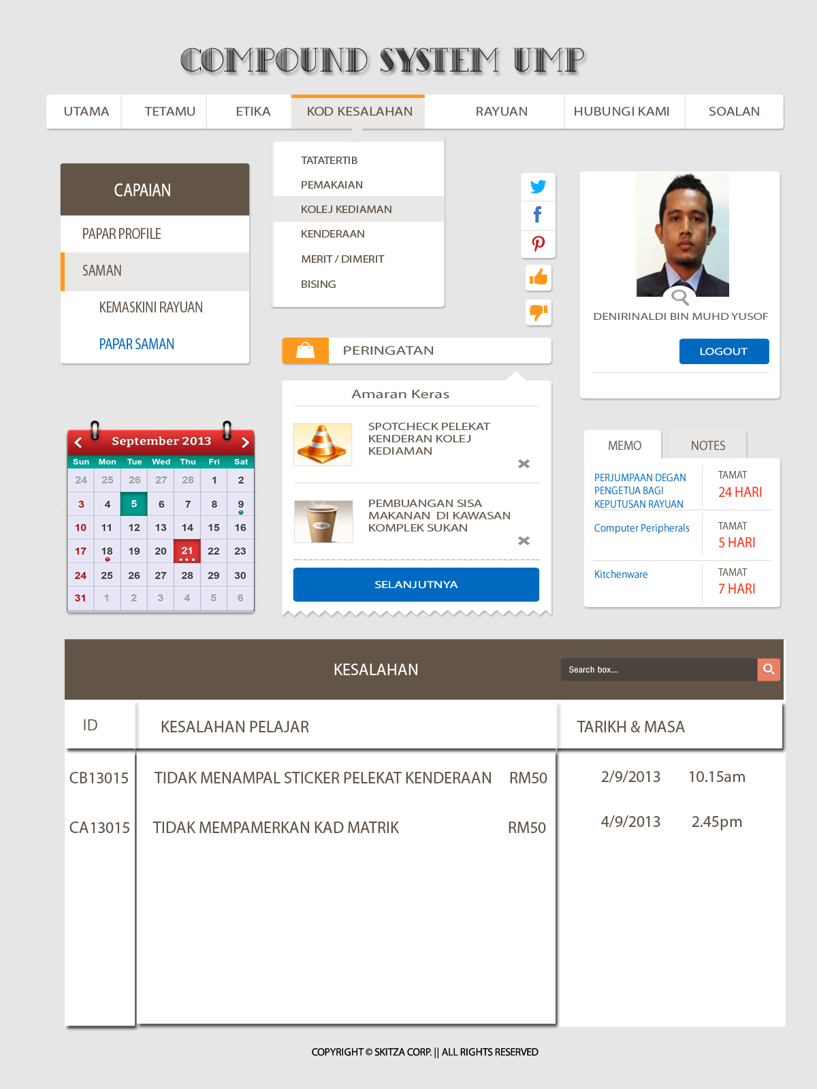

**Appendix B-10** Principal view Summon Information

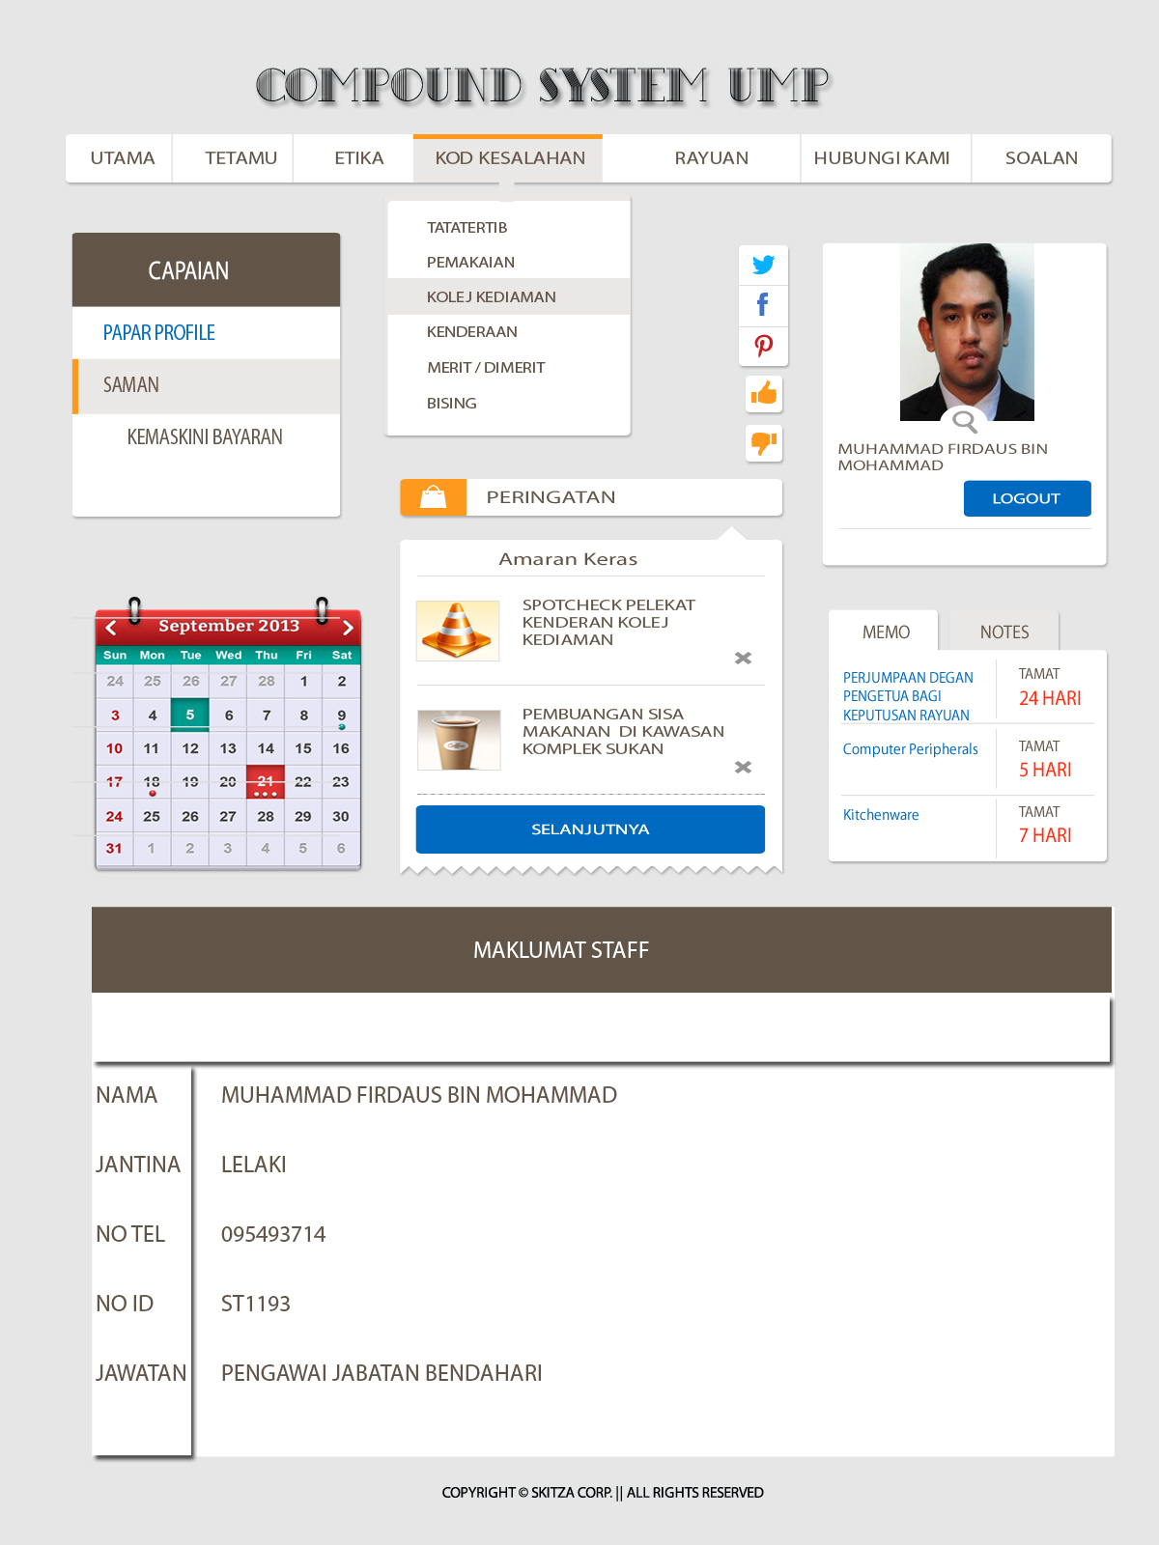

**Appendix B-11** View treasurer profile

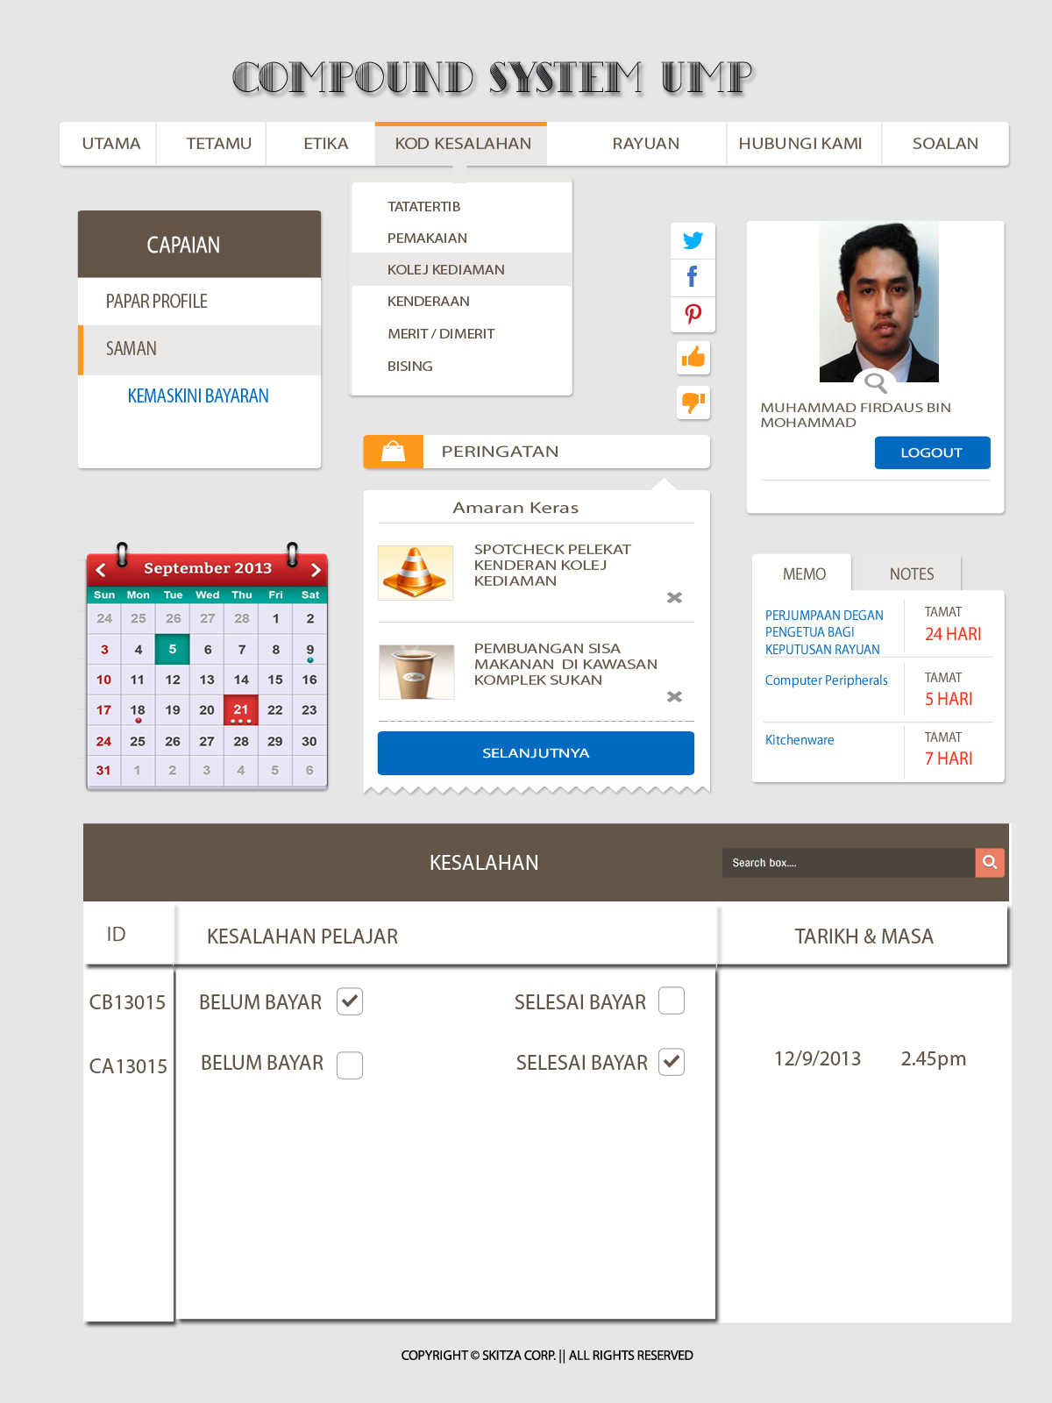

**Appendix B-12** Treasurer update student payment

1.